School supply list. Frist day of school is August 31st

School Supplies List for all students 1years to 4years old
- Large pencils for ages 3, 4 and 5
- Colored pencils
- Pencil sharpeners ages 3, 4 and 5
- Erasers ages 3,4 and 5
- Pencil case ages 3,4 and 5
- Glue sticks all ages
- Crayons big crayons please all ages
- Washable markers all ages
- Watercolor paints (8 ct.) all ages
- Pair of scissors (safety) all ages
- Pocket folders at least 3 for all ages
- Lunchbox N/a
- Backpack n/a
- Construction paper one pack
- Wide-ruled notebook n/a
- Hand sanitizer if you can find it one bottle please
- Box of tissues 2 boxes
- Old shirt for painting
- * Our dress code this year is again dark blue, Khaki pants, skirts or shorts. Polo tops only: Red, white, Blue, green pink. If you find polo dresses the girls and wear them.
- Chapel on Wednesday: Dark or Light blue polo with Navy bottoms only!
- Friday green Spirit shirt with jean. If you do not have a shirt then regular uniform without jeans.
- Zumbini will start again the first week of school on Thursday August 3rd. The additional payment of 9.92 will start for all students then. You are not required to buy bundles this year however if you would like to the cost of a bundle are now only 20.00. This includes a plush doll, songs, and book of the character we will learn about. This month is a new one his name is TJ.
- We are looking for a great school year.
- This year our 3 year old class and our prekinder class will need to purchase the student work book. You can buy it new or gently used.
- 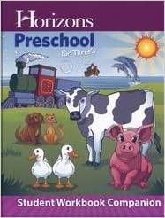3-year old’s
- 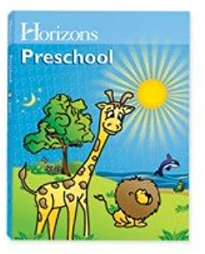Four year old’s

