Look Book Guide

1. Cover Page (Name of Program with a Picture)
2. Mission Statement
3. “What Does Quality Look Like? Let’s Take a Tour” page
4. Infants

* Daily Schedule
* Pictures of the infant classroom

1. Toddlers

* Daily Schedule
* Pictures of Toddler classroom

1. Twos

* Daily Schedule
* Pictures of Twos classroom

1. Preschool

* Daily Schedule
* Pictures of Preschool@  
  “:?

1. VPK

* Daily Schedule
* Pictures of VPK

1. Playground
2. What separates our program from others?
3. Tuition/Rates/Fees
4. Parent Feedback

(**Living Well Christian Academy**)

Look Book



Mission Statement

We at living well daycare believe that it is important to prepare children for their future...  
 and that every child has the potential to bring something unique and special to this ever-changing world. We will help children to develop their potential by believing in them as capable individuals in a loving Christian environment. We will assist children with biblical principles and with educational professionalism, discover who they are, so they can express their own opinions and nurture the ideas that God has given them. We have a vision of a world where people learn to respect, accept, and embrace the differences between us, as the core of what makes life so fascinating with the premise of biblical guidelines and our faith.

If children are trained up in the right direction, later in life they will not depart from what they have been taught. This is our Motto: Teach children how they should live, and they will remember it always.  
Every classroom presents a unique community of learners that varies not only in abilities, but also in learning styles. Our role as teacher's and child development associates are to give children the tools with which to cultivate their own gardens of knowledge. To accomplish this goal, we will teach to the needs of each child so that all learners can feel capable and successful. We will present a Christian curriculum that involves the interests of the children and that makes learning relevant to life. We will incorporate themes, integrated units, projects, group work, individual work, and hands-on learning in order to make children active learners. Finally, we will tie learning into the world community to help children become caring and active members of society.

It is important to show each child how beautifully created they are which will give them a sense of Christian pride...  
Our classrooms are caring, safe, and equitable environments where each child can blossom and grow. We allow children to become responsible members of our classroom community by using strategies such as class meetings, positive discipline, and democratic principles. In showing children how to become responsible for themselves as well as their own learning, we are giving the children the tools to become successful in life, to believe in themselves, and to love themselves.

It is important that each child feels safe and happy.  
Teaching is a lifelong learning process of new philosophies and new strategies, learning from the parents and community, learning from colleagues, and especially learning from the children. Children can teach all of us to open our minds and hearts to the joys, the innocence, and the diversity of ideas in the world.  And at Living Well Daycare we are dedicated to never forget how to smile with the new, cherish the old, and laugh with the children.



What Does Quality Look Like?

Let’s Take a Tour!

Infant Classroom

Teachers: Ms. Marinel & Ms. Dori

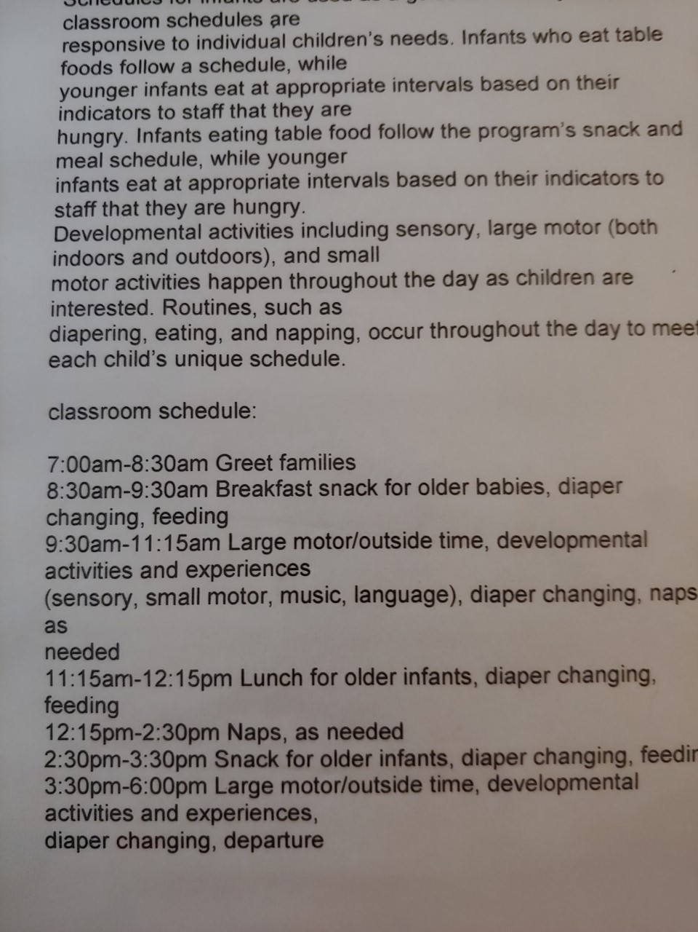

Welcome to Infants! Take a peek inside our classroom.

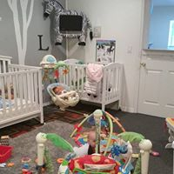

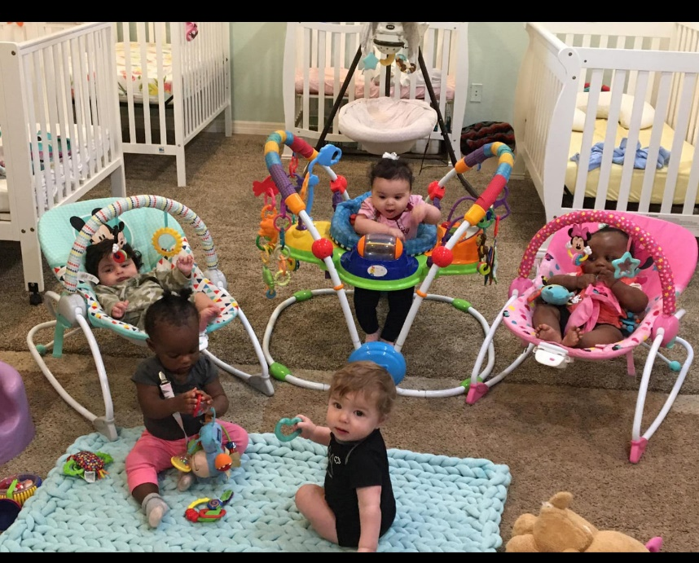

Toddler Classroom

Teacher: Ms. Baily

Example:

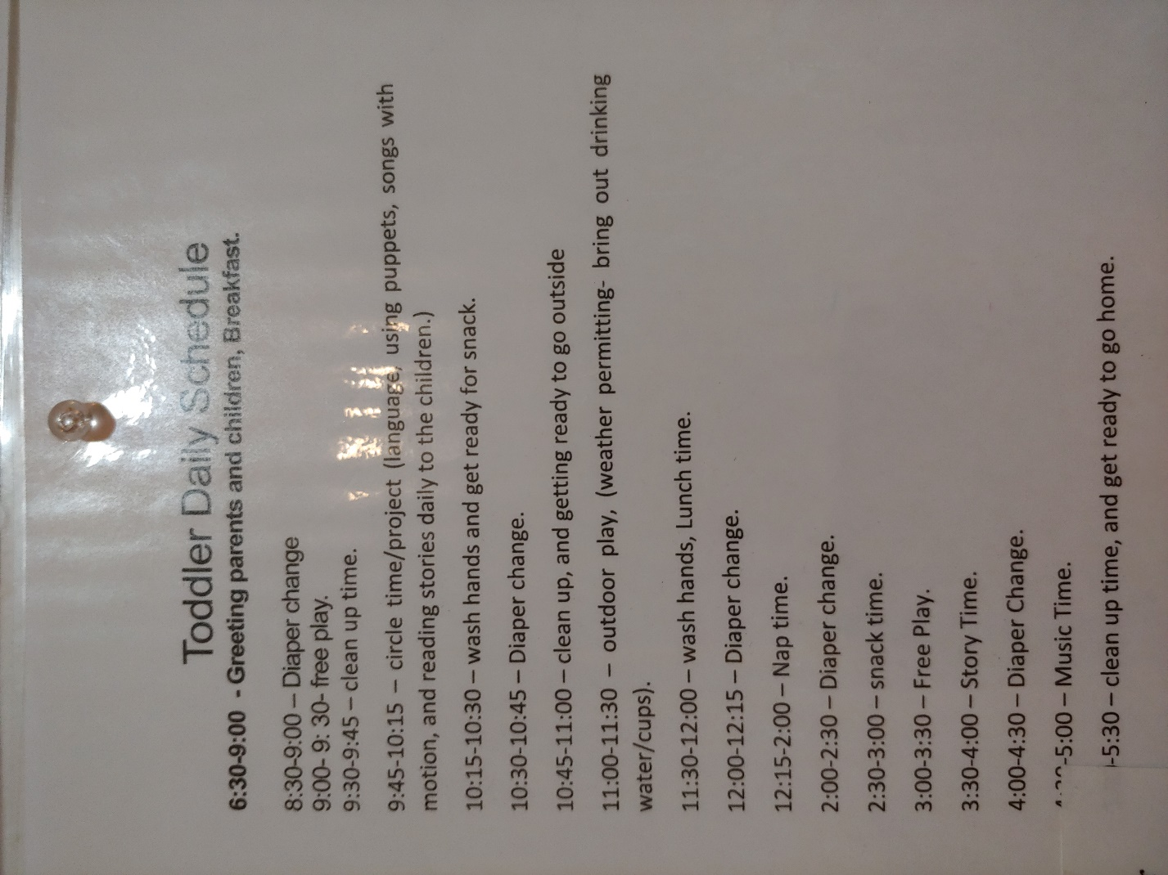

Welcome to the Toddler Classroom where we love to explore and have fun!

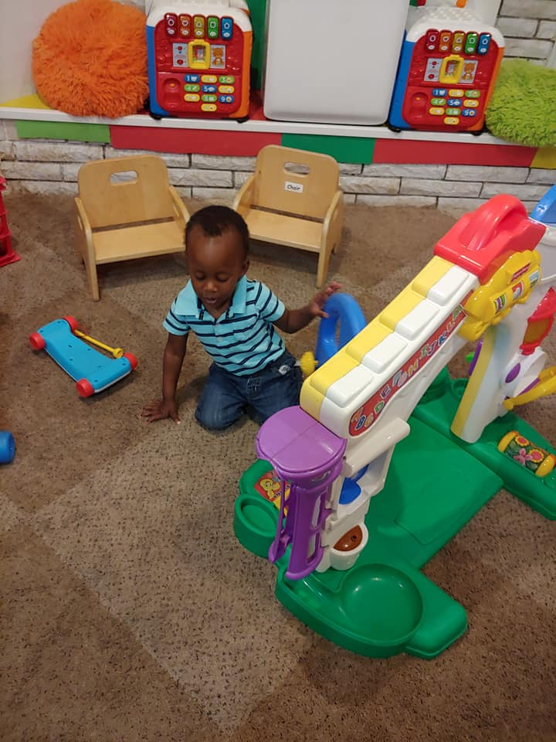

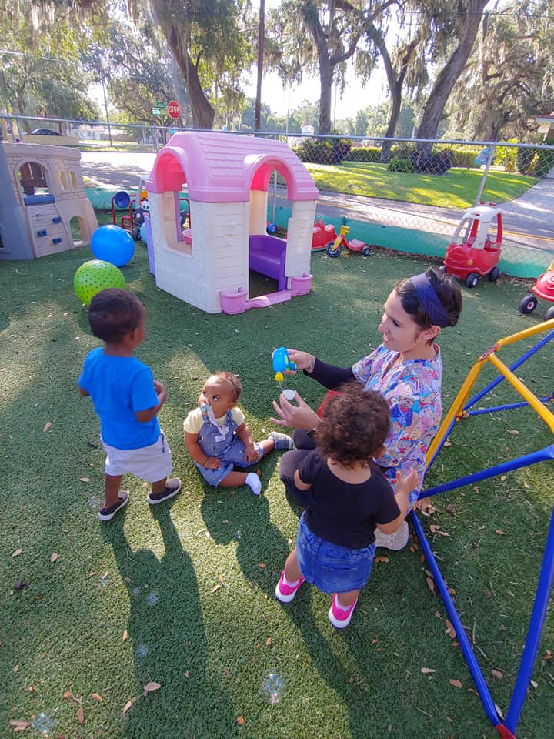 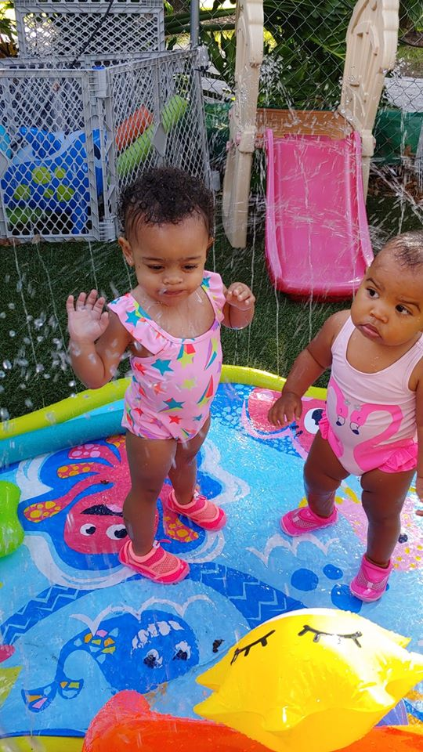

Twos Classroom

Teachers: Mrs. Faith

Example:

[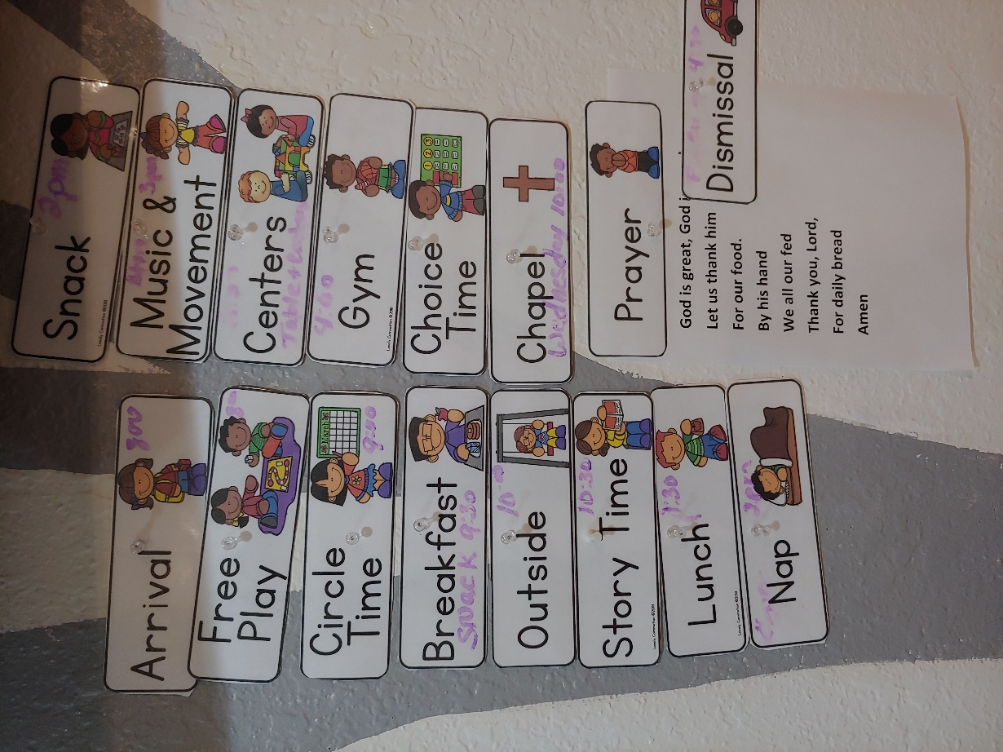](https://www.bing.com/images/search?q=3rd+Grade+Classroom+Daily+Schedule&FORM=IRIBIP)

Welcome to the Two’s classroom!

We are learning to become independent and to develop our social skills.

[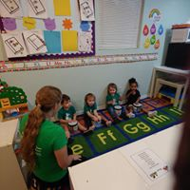](https://www.bing.com/images/search?view=detailV2&ccid=1HgUtCkf&id=646EB594BB74588C5C03AEE56ED13F582D56ED01&thid=OIP.1HgUtCkfeq03KUnPxnTmZwHaFj&mediaurl=https%3a%2f%2fwww.psych.ucla.edu%2fsites%2fdefault%2ffiles%2fimages%2fFernaldScience.JPG&exph=720&expw=960&q=twos+exploring+classroom&simid=608039988805569708&ck=5E122F91C3CA0F50C98E088DBBD1FC44&selectedIndex=0)

[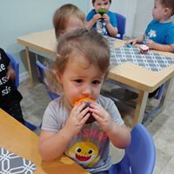](https://www.bing.com/images/search?view=detailV2&ccid=Qqqqhr69&id=0B3E74C8215E14777977CD7FF42229A0EF2CA81E&thid=OIP.Qqqqhr69w9cXQPPJFIoaXgHaFj&mediaurl=http%3a%2f%2fwww.hillsdales.org%2fsite%2fwp-content%2fuploads%2f2011%2f02%2fIMG_0385-e1424453021540.jpg&exph=2448&expw=3264&q=twos+exploring+classroom&simid=608019351400218990&ck=05E6913AA24A40DC4B3D2828D77A1634&selectedIndex=2) [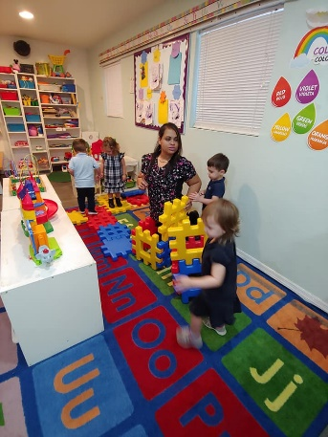](https://www.bing.com/images/search?view=detailV2&ccid=Xq5k05Jd&id=F7942CA221389A3CB368D4C4E8A1CE26D470DFB7&thid=OIP.Xq5k05JdmT9TvG3H_sbQaAHaE7&mediaurl=https%3a%2f%2fdayearlylearning.org%2fwp-content%2fuploads%2f2018%2f01%2f33630963110_de7b2aa54f_k-1.jpg&exph=1363&expw=2048&q=twos+exploring+classroom&simid=608000732727607971&ck=19D7E0B659B0AA24B1BF07DF4E889030&selectedIndex=1)[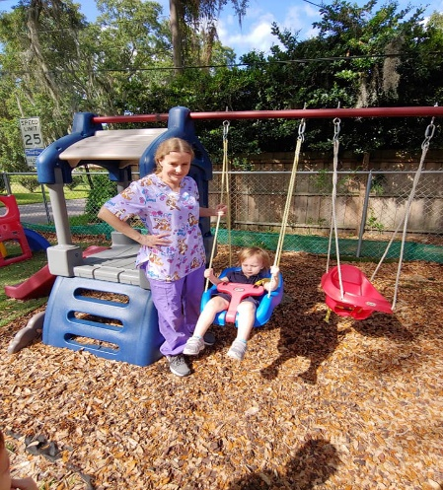](https://www.bing.com/images/search?view=detailV2&ccid=i1mY2Md2&id=B34DECA0E7EBE4DD17BBC539632F7EE03C082F2F&thid=OIP.i1mY2Md2b6R8M7CoQVbXfgHaEX&mediaurl=http%3a%2f%2fwww.discoveryprograms.com%2fwp-content%2fuploads%2f2014%2f01%2fart-for-tots-Discovery-class-NYC-for-child-to-explore-shape-color-texture-paint.jpg.jpg&exph=380&expw=645&q=twos+exploring+classroom&simid=608025372944828303&ck=A53D1663C74DEA26D3004FE6D7885FEB&selectedIndex=3)

Preschool

Teachers: Mrs. Annette & Mrs. Racheal’s class

[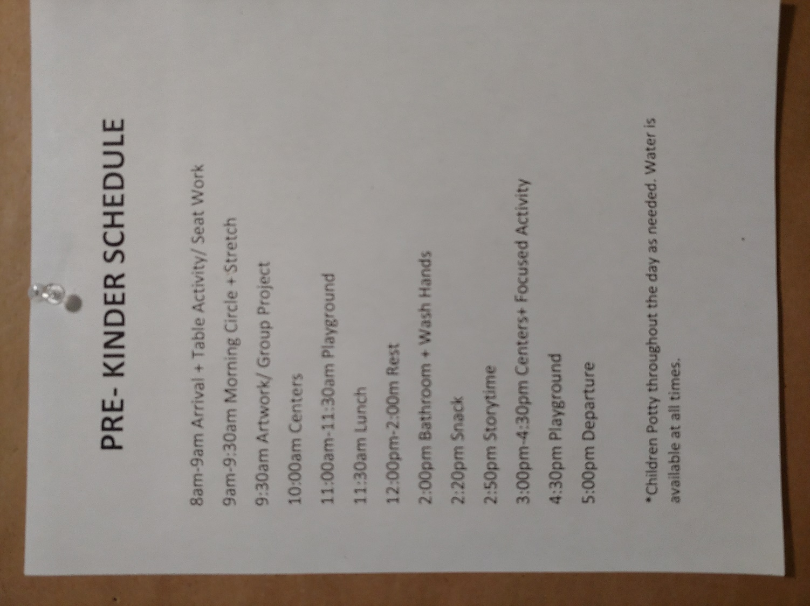](https://www.bing.com/images/search?view=detailV2&ccid=3Yo8xdo7&id=55D0555C150B8E10139FF6B86FF18B48D6C0BC1F&thid=OIP.3Yo8xdo7FP4QRWMsdZ25iAAAAA&mediaurl=https%3a%2f%2fi.pinimg.com%2f736x%2f47%2f3c%2f17%2f473c17b296676307ecabe1082558242c--preschool-schedule-preschool-classroom.jpg&exph=425&expw=400&q=preschool+Classroom+Daily+Schedule&simid=608046362465011269&ck=136F93F2F974A3FE6E55E3270861B28A&selectedIndex=26)

Welcome to the Preschool Classroom!

[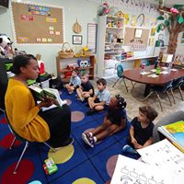](https://www.bing.com/images/search?view=detailV2&ccid=s0nd%2f%2fGN&id=73595ECF215433CDB98BC666D3FB3F4EAB7D972E&thid=OIP.s0nd__GN2BuFA_ntX2EzsQHaE8&mediaurl=http%3a%2f%2fmvppreschool.org%2fwp-content%2fuploads%2f2016%2f11%2fDSC_0051.jpg&exph=4000&expw=6000&q=preschool+classroom&simid=608022482494033673&ck=95139682921E2F010E4AC374F5DAF27D&selectedIndex=14) 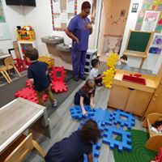

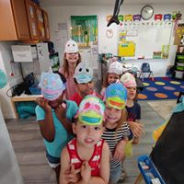 [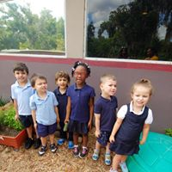](https://www.bing.com/images/search?view=detailV2&ccid=8r4Exn%2f5&id=6160C58D581FE55C06386CC6A5FD40CB5EE5F49E&thid=OIP.8r4Exn_5nnMzv1Ph3HdgYgHaE8&mediaurl=https%3a%2f%2fuploads.thealternativepress.com%2fuploads%2fphotos%2f4f%2fbest_b625d5af667a2334f01e_Preschool_Classroom.JPG&exph=2592&expw=3888&q=preschool+classroom&simid=608042883618702228&ck=743CB7ECB7201AD8EB05A0A17659D030&selectedIndex=4)

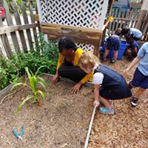

Pre-Kinder’s

Teacher Mrs. Annette

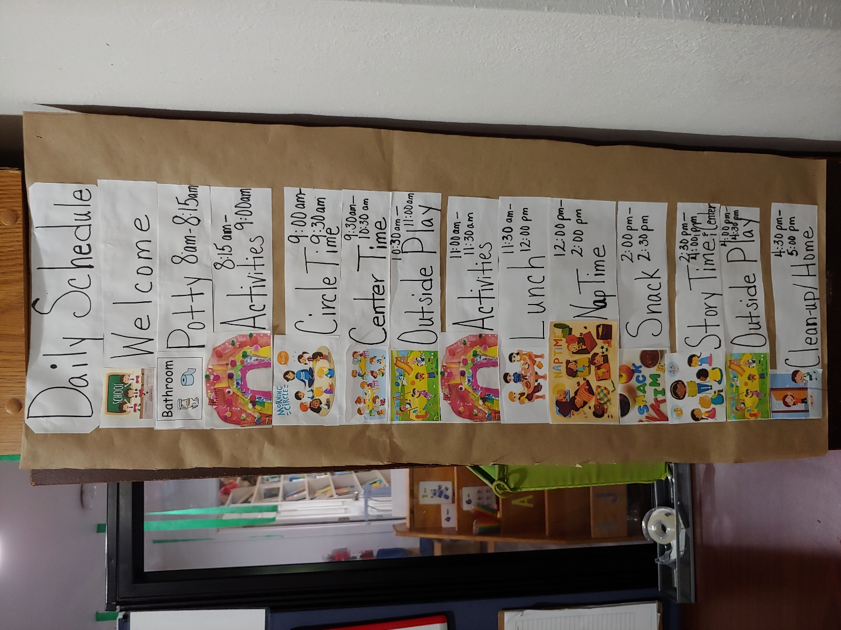

[](https://www.bing.com/images/search?view=detailV2&ccid=KyM4ZmG0&id=CD41527502B3406551EA07C94DB8EF1898D78BAD&thid=OIP.KyM4ZmG0XGlEQaTmyerCmAHaE8&mediaurl=http%3a%2f%2fworldofkidsacademy.com%2fwp-content%2fuploads%2f2017%2f04%2fWOK_LoRes-10-1-1024x683.jpg&exph=683&expw=1024&q=vpk+classroom&simid=608011487418059699&ck=9D7341C6B91B273F00B08C0C72970E0A&selectedIndex=4)Welcome to our school readiness program where we learn and play!

[](https://www.bing.com/images/search?view=detailV2&ccid=RoprRDZr&id=DA931AD9A5DF54CA01D1CEA6F39E56C7B8E5E9BB&thid=OIP.RoprRDZr1ONzIweB30q-OwHaFj&mediaurl=https%3a%2f%2fs-media-cache-ak0.pinimg.com%2f736x%2f24%2f3c%2fdf%2f243cdff6350da87e3b35343d5eb1e04e.jpg&exph=552&expw=736&q=vpk+classroom&simid=608003026261903353&ck=7AF840508BA57A4BA2FA764FD384C18D&selectedIndex=22) [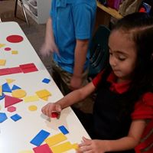](https://www.bing.com/images/search?view=detailV2&ccid=abxacS9j&id=8092A813357E872DDB5E4AC5811FDEBC8E251C43&thid=OIP.abxacS9jiGk2Ng6kXK9dUAHaE7&mediaurl=https%3a%2f%2fthelearningladder.org%2fwp-content%2fuploads%2f2016%2f05%2fvpk9.jpg&exph=586&expw=880&q=vpk+classroom&simid=607986782705681156&ck=120CDCB113FD5685A565F17C3EA65B5D&selectedIndex=112)

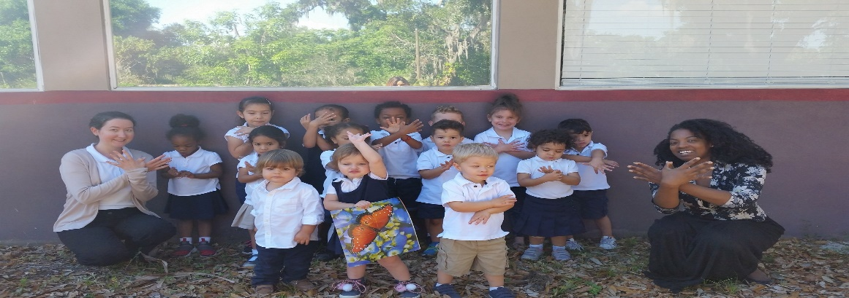

Peek at our Playground!



[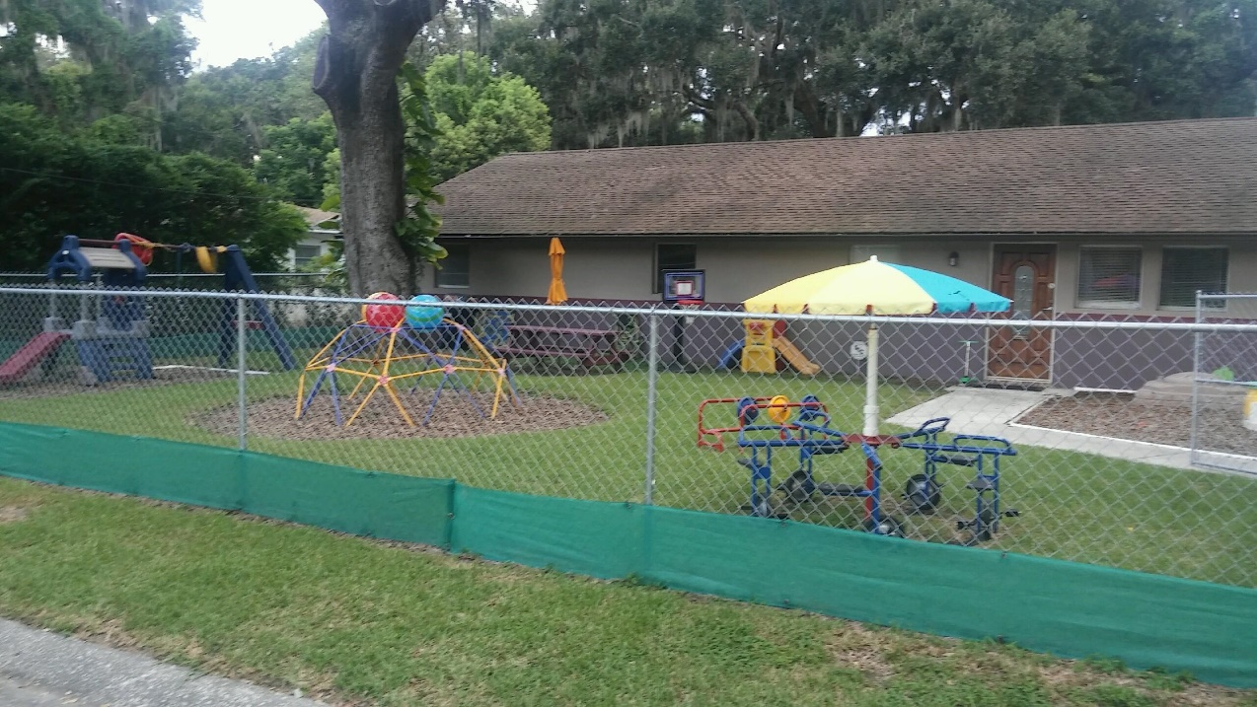](https://www.bing.com/images/search?view=detailV2&ccid=CrJg2HwV&id=9C7D3C0E5A0A500E9F4449E8CF60F129140C605B&thid=OIP.CrJg2HwVWR0gfqkreUX-YgHaE8&mediaurl=https%3a%2f%2fcontent.pentagonplay.co.uk%2fcompleted-photos%2f24635%2f8394%2fLarge%2fplayground-safety-surfacing.JPG&exph=1000&expw=1500&q=playground+preschool&simid=608012775934267162&ck=5F86C9866123BDFEC04AD0201CF49873&selectedIndex=6)   
[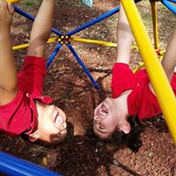](https://www.bing.com/images/search?view=detailV2&ccid=1yDmJ6mU&id=67B93B87793F427AF7B93D2B23A3934A6CDA64EA&thid=OIP.1yDmJ6mUsGtuqdPhZJtJcgHaC4&mediaurl=https%3a%2f%2fwww.playlsi.com%2fglobalassets%2fplaygrounds%2fseo-filter-pages%2fcomponent-playsystems%2fweevos%2fweevoscomp_1440.jpg%3fwidth%3d767&exph=298&expw=767&q=playground+preschool&simid=608015997136931900&ck=34B5EDFAC0BD02F5C1C33371072C1487&selectedIndex=13)

What Separates Our Program from Others?

We stand apart from other daycare’s because of our Christain value’s, lower ratio’s and our Zumbini program (music and movement) which is offered every Friday during the school year. Our trained Zumbini instrutor, incorporates the Zumbini program within the school’s curriculum.

Give your little one, A Healthier, Happier, More Enjoyable Start

Through 6-16-week sessions, we not only nurture their love of movement, so it becomes a way of life.

In addition we also teach the student’s, gardening using the Tower Garden system. The students are able to plant and grow their own veggies within our vertical gardening system. It requires only water and nutrients.

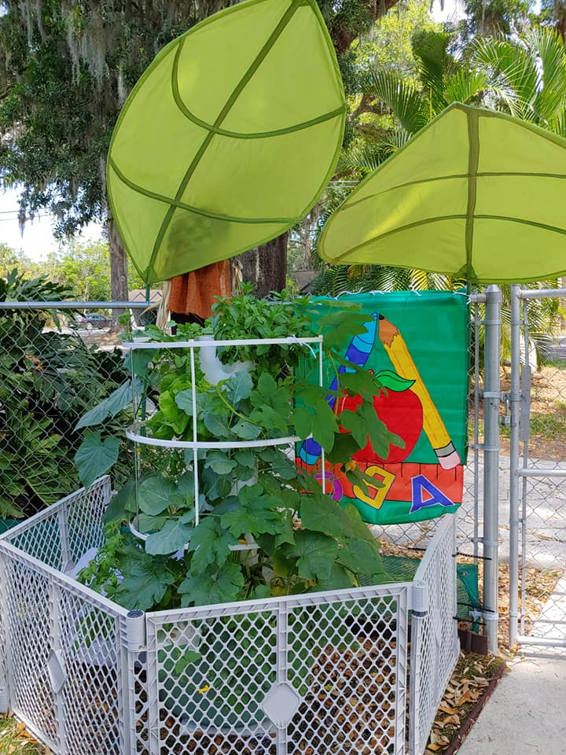

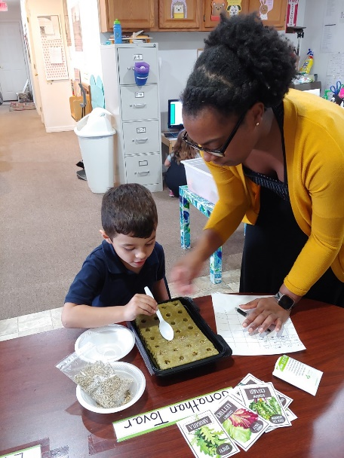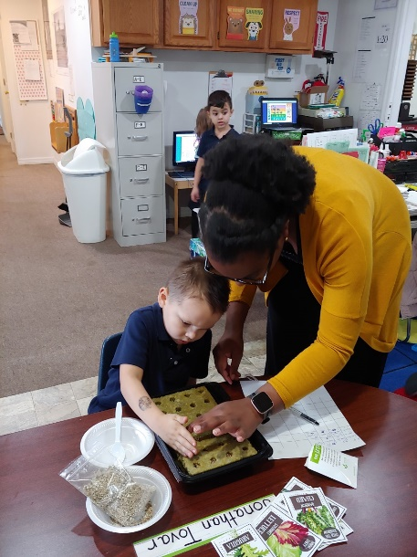

Parent Feedback & Reviews

Here’s a glimpse of what our families have to say:

**“My children started this month and I love everything about this Daycare! The staff is wonderful, and they love our children! God is always on time! We really needed a great daycare and God gave us Living Well!   
Thank you!”**

**“God answered our prayers with this daycare! I love to see the smile on my little boy’s face when I drop him off”**

**“This is an amazing little school! The teachers and staff are beautiful, caring, and loving towards all the children they work with. I could not ask for a better place to take care of my children”.**

**“Love the environment both for children and workers”!**

**“First off let me say this, When Mrs. Theresa called me about my inquiry, I had such a good feeling about her. She was extremely pleasant over the phone and highly informative. I visited the daycare yesterday and I have absolutely nothing negative to say. Everything was organized and I also got to meet my daughter's teacher. My daughter walked into this daycare like she has been there before, interacted with both Ms. Theresa and her teacher like she had known them forever. By the end of the visit she was blowing them kisses. I cannot wait for her to start. I can tell it is going to be a terrific school year. Another thing that was a plus for me is that this is a CHRISTIAN daycare. I want these values to be instilled in my child even when she is away from me. You will not regret your decision in selecting this daycare”.**

**Tuition and Fees**

$50 Application Fee to Hold Spot

Infants: $195.00 a week

Toddlers: $185.00 a week

Twos: 175.00 a week

Preschool: 165.00 a week

VPK: 150.00 a week

Our part time rate is 45.00 daily and we require that your child attend, 3 days a week.

Our fee for Zumbini is an Extra 9.92 a week from September – June.

Our motto is from Proverbs 22:6

Teach children how they should live and they will remember it always!

