Supportive Transiting from the Infant room to the Toddler room at Living Well Daycare

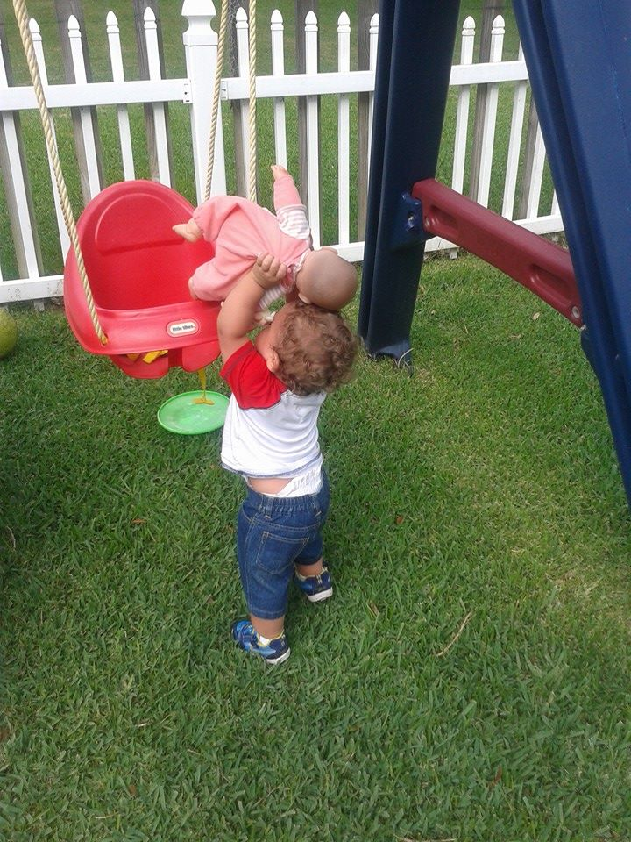Congratulations your baby is moving up to a new classroom here at living Well daycare.
This is what you can expect from your new teacher: The toddle room is set up to meet the developmental needs of the children that are one years old and continues until they are two.
Gross Motor: This area encourages children to use their large muscles through climbing, block play, music, and movement. Make sure that your child comes to school with closed toe shoes for their safety.
Dramatic play: this area encourages children to engage in role- playing activities with the use of props such as kitchen, table and chairs, vacuum, dolls and trucks and cars.
Quite: this area allows children a place to retreat for some quite time. Our teacher may get out books and have the students lay on their tummies and point out pictures this encourages children to develop language/literacy skills using books and soft toys and develop fine motor coordination with the use of manipulatives.
Sensory: This area encourages the children to express themselves and be creative through art and various activities.
To maximize children’s potential in developing all the above-mentioned skills, they need to come to the classroom on a regular basis and engage in hands on activities that utilize their senses.
All the developmental changes that occur during the toddler’s years—increased language, budding independence, and beginning awareness of peers must be considered when developing a program. Sometimes the most developed and well carefully planned program will need to be adjusted to meet the children’s individual needs and reactions. Your toddler will find consistent routines to be a comfort. Morning good-bye routines are very important to your toddler. Your teacher will work with you to cut down on toddler frustration and optimize their learning experience.
A typical day in the toddler classroom consist of arrival, playtime, snack, playtime, lunch, naptime, snack playtime and departure. Children at this age learn most through play. We follow a pattern of events throughout the day so that your toddler will know what to expect. For example, in the toddler room naptime follows lunch time.
Diapering takes place when needed and occur throughout the day.
When planning to bring food for your toddler remember to
- Keep portions realistic: remember that they do not need a full serving and have little tummies that fill up very quickly. Start small and provide extra so that we can serve more if your toddler is still hungry.
- Accept the mess: mealtime is meant to be sensory. Toddlers appreciate the smell and taste and texture nuances that eating can offer. It will involve a mess. Please bring extra clothing.
- We want to make sure that every bite counts so when you are bringing food make sure they get a protein, starch and fruits and veggies. If they do not eat all their food at lunch, we will make sure that the mid-morning and afternoon snack make up for foods not eaten.

Our Curriculum ABC Jesus Loves me is designed for specific objectives for each age level. The classroom is set up to create an environment that is rich with learning opportunities, safe, nurturing and developmentally appropriate.
The following goals are set into every classroom
- Developing safe and healthy habits
- Fostering positive self esteem
- Opportunities for creative expression
- Supporting social skills
- Strengthening communication skills necessary for listening, reading, writing, and speaking
- Enhancing fine and gross motor skills
- Assessing individual needs of each child
Your toddler will have the opportunity to move freely and achieve mastery of their bodies through self-initiated movement and practice skills in coordination, movement, and balance.
*develop fine motor skills by using their hands and fingers in a variety of age appropriate way.
* use books, songs and rhymes and games
*Use language gestures and materials to convey concepts such as “more”, and less, big and small. They will see and touch different shapes and textures along with colors to build awareness.
* express themselves freely to music and engage in pretend or imaginative play.

As your infant enters the toddler years they become more independent and want to do more things these are some of the things your teacher will help with in the toddler room:
- Drink from a cup
- Sleep on a cot
- Build expressive vocabulary of 200+ words
- Eat with a spoon
- Develop fine motor skills
- Understand books
- Engage in sensory activities
- Refine balance and coordination with outside play
- Social skills
- Gain understanding of color, shapes cause and effect opposites and so on….

To help your child transition it will be helpful too:
*Offer your child a cup to drink out of on a regular basis
* Try to extend their nap time is see if they can make it to 12:00
*Consider your child’s transition from formula to whole milk or milk of choice
*Increase solid foods
* practice packing lunch for your child and experiment with various table foods.
*begin to limit the use of pacifier
*Let your child practice wearing closed toe shoes.
* Allow your child to play independently with planned activities.
* allow time for your child and teacher to get to know each other.
Please ask your teacher for ideas of what types of food to bring if you are in question.
This is a guide to help your child better transition from the infant room to the toddler room. If you have any future questions or concerns, please talk with your child’s new teacher to better help you.
Your child will have a new cubby with their name on it. It is place in the front hallway with the number one on it. All his/her belonging will go in the red basket and at the end of the day his/ her teacher will place items that need to go home. Food items should be place in the toddler room. Mrs. Melba has a food cubby in the room and in the small refrigerator so that you can place items such as wipes, diapers, and foods in them.

Living Well Infant to toddler Transition Family Work sheet
Child’s name________________________________DOB__________________
Current classroom___________________ New Classroom__________________
Parents/Family name________________ Date Moved_____________________
Transition Part 1- Review current assessment data for the child: discuss developmental tasks to be encouraged prior to the child’s transition/move to toddler room.
____Gross Motor- standing alone: walks alone: 5 steps without falling: get into a standing position without using hands
____Fine Motor_ uses pincer-like grasp to obtain objects: marks with a crayon/scribbles
____Cognitive/language/social and emotional- Responds to verbal request, follows simple instructions’ jabbers expressively; points and vocalizes to indicate wants: gives toy to an adult upon request
____Self-help- finger feeds self, chews most food well, cooperates in dressing, overcomes simple obstacles.
_____At home task- Practice drinking from a cup, extended naptime, whole milk or alternative transition, increased solid food, decreased baby food and bottles, limited use of pacifier.
Part one conference completed _____/date______Parent Signature___________________________

